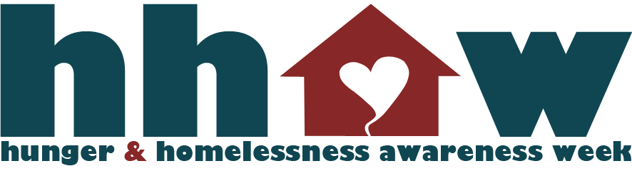
November 15th-21st, 2009

For Immediate Release:
Contacts:
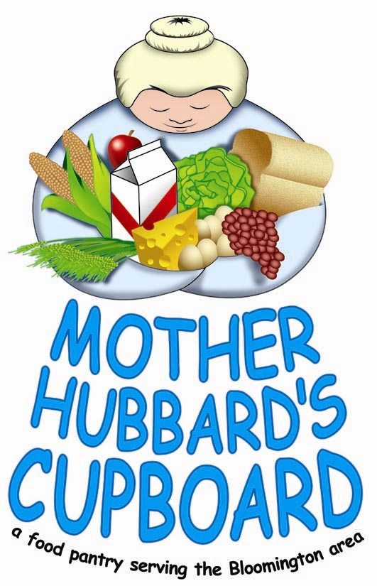
Joel Rekas, Executive Director Bobbie Summers, Executive Director
Shalom Community Center Martha's House
(812) 334-5728 (812) 332-1444 joel@shalomcommunitycenter.org
bsummers409@hotmail.com
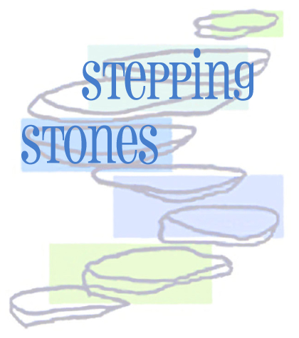
Sheri Benham, Executive Director Brooke Gentile, Executive Director
Stepping Stones Mother Hubbard's Cupboard
(812) 339-9771 (812) 355-6843
sbenham@steppingstones-inc.org brooke@mhcfoodpantry.org

This year National Hunger & Homelessness Awareness Week is Sunday, November 15th – Saturday, November 21st, 2009. Shalom Community Center, Martha’s House, Stepping Stones, Mother Hubbard’s Cupboard and IU INPIRG are collaborating to bring a week of events to Bloomington, IN, focusing the community's attention on issues of hunger and homelessness. The educational and fundraising events invite Bloomington residents to “see more, learn more, and do more”, while highlighting the need in our community and the work agencies perform everyday to help people transition out of poverty.

- City of Bloomington Issues Proclamation on Hunger and Homelessness Awareness Week
Saturday, November 14th Showers Atrium.
The Office of the Mayor? with the City of Bloomington issues a Proclamation declaring that Sunday, November 15th – Saturday, November 21st is Hunger and Homelessness Awareness Week in Bloomington, IN. This is the kick-off event for the week of activities. Open to the public.

- "What Home Means to Me" Photo Project
Saturday, November 14th-Saturday, November 21st - Showers Atrium
Clients of Shalom Community Center, Mother Hubbard's Cupboard, Stepping Stones, and Martha's House were recruited to take pictures to represent "What Home Means to Me". These photos with a brief summary describing the meaning behind the photograph will be displayed in the Showers Plaza atrium. Some may appear in The Herald Times Online as well.

- "Show and Tell: Stories of Poverty"
Monday, Nov. 16th Rachel's Cafe at 7 p.m. on

- Spare Change for Social Change
Sunday, November 15th-Saturday November 21st The Bloomington community is invited to support our efforts by donating spare change to the many collection cans around town during Hunger and Homelessness Awareness Week. Look for the Awareness Week logo on cans in your local businesses. All funds will be donated to Shalom, Martha’s House, Stepping Stones and Mother Hubbard’s Cupboard.

- Are You Smarter Than a Fifth Grader? Thursday, November 19th, doors open at 6:30pm, and show starts at 7:00pm
Bloomington High School South
The culminating event for Hunger and Homelessness Awareness Week is an evening with fifth graders and local celebrities in a Bloomington exclusive “Are You Smarter Than a Fifth Grader?” episode. Food Drives and Essay Contests were held at participating schools to determine student contenders. Pam Thrash (B97), Dr. Malone (Southern Indiana Pediatrics), an Acacia Fraternity member and three people selected by MCCSC will take on the 5th graders. Darrel Neher will be the Emcee host for the evening. Tickets on sale at Sun Rise Box Office, Bloomingfoods, Martha’s House, Mother Hubbard’s Cupboard and Shalom: $10 and kids 5 and under are free. This event is a benefit for Shalom Community Center, Martha’s House, Stepping Stones and Mother Hubbard’s Cupboard. Sponsored by: Cassady Electrical Contractors

- IU Student Food Stamp Challenge
Sunday, November 15th- Saturday November 21st
On IU campus, the Indiana Public Interest Research Group (INPIRG), is organizing 5 students to take part in the Food Stamp Challenge. Participants may spend only $21 on food and beverages for the week. $21 is the average food stamp allotment per week for an individual in the United States. The challenge is to “live the life” of a food stamp participant which will offer valuable insight into the struggles of people in poverty while helping the community and campus gain a better understanding of these issues.

- Playing for Change – A CD Release Party
Saturday, November 14th, 8pm, Players Pub
Shalom will host the launch of "Playing for Change," a CD featuring the music of Kent Johnson, accompanied by more than a dozen other artists (including Sylvia McNair). Kent and several of the featured musicians will perform live and CDs will be available for sale. Tickets are $5 at the door or at Sunrise Box Office. CDs are $20. This is a benefit for Shalom Community Center

- Mother Hubbard’s Cupboard: “Share the Harvest” Auction and Gala
Saturday, November 14th, 6:30-9:30pm, KRC Catering Hall
Join Mother Hubbard’s Cupboard (MHC) for an evening of spirited fun and generous giving. Exciting live and silent auction marketplaces, delicious food and great music! Enjoy the performance by The Postmodern Jazz Quartet. $25 tickets available at Relish, Sun Rise Box Office, Bloomingfoods and MHC. This is a benefit for Mother Hubbard’s Cupboard.

For more information about National Hunger and Homeless Awareness Week events in Bloomington, visit http://hhaw.tumblr.com/

